Biddenden Bowls Club Equity Policy Statement
Biddenden Bowls Club respects the rights, dignity and worth of every person and will treat everyone equally within the context of their sport regardless of age, disability, gender reassignment, race (including ethnic origin, nationality and colour), religion or belief, sex (gender), sexual orientation or social/economic status.
Biddenden Bowls Club is committed to ensuring that equity is incorporated across all aspects of its development. In doing so it acknowledges and adopts the following Sport England definition of sports equity:
“Sports equity is about fairness in sport, equality of access, recognising inequalities and taking steps to address them. It is about changing the culture and structure of sport to ensure that it becomes equally accessible to all members of society, whatever their age, ability, gender, race, ethnicity, sexuality or socio-economic status.”
Biddenden Bowls Club is committed to everyone having the right to enjoy their sport in an environment free from threat of discrimination, intimidation, poor practice, harassment and abuse.
All Club members have a responsibility to challenge discriminatory behaviour and promote equality of opportunity.
Biddenden Bowls Club will deal with any incidence of discriminatory behaviour seriously, according to our disciplinary procedures.

First Adopted 21st March 2019. Updated May 2022

Why is this an equity policy rather than and equality policy?
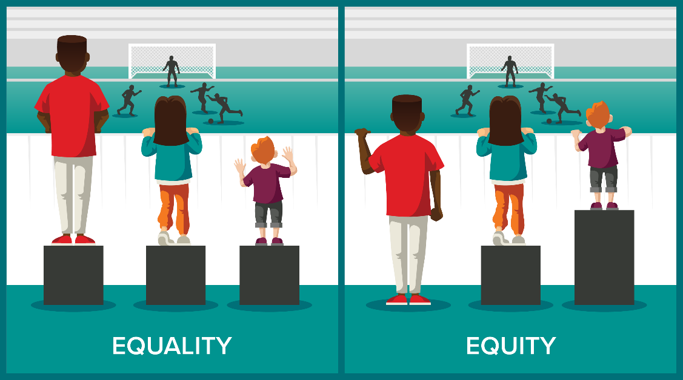

What is Equality?
The Equality and Human Rights Commission describe equality as: “Ensuring that every individual has an equal opportunity to make the most of their lives and talents.”

What is Equity?
Equity is about giving people what they need in order to make things fair.
This is not the same as equality, nor is it the same as inequality. It is simply giving more to those who need it, which is proportionate to their own circumstances, in order to ensure that everyone has the same opportunities.

Equality vs. Equity
The difference between equality and equity: both promote fairness
Equality achieves this through treating everyone the same regardless of need, while equity achieves this through treating people differently dependent on need. However, this different treatment may be the key to reaching equality.

